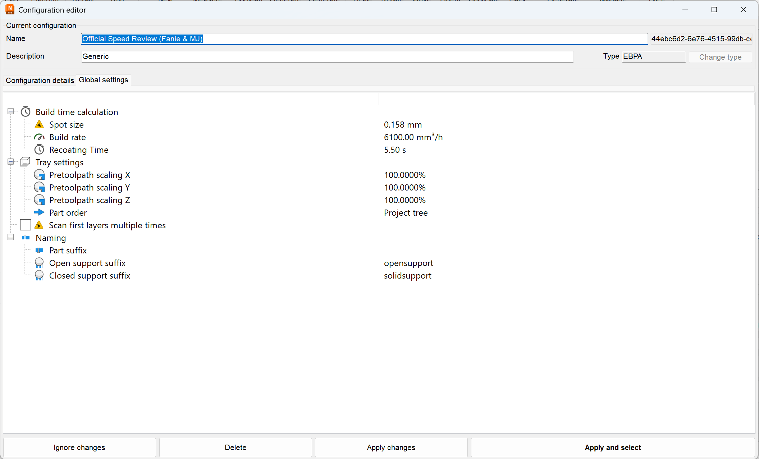
Unknown
Unsure
Known
Known
Unsure
Known
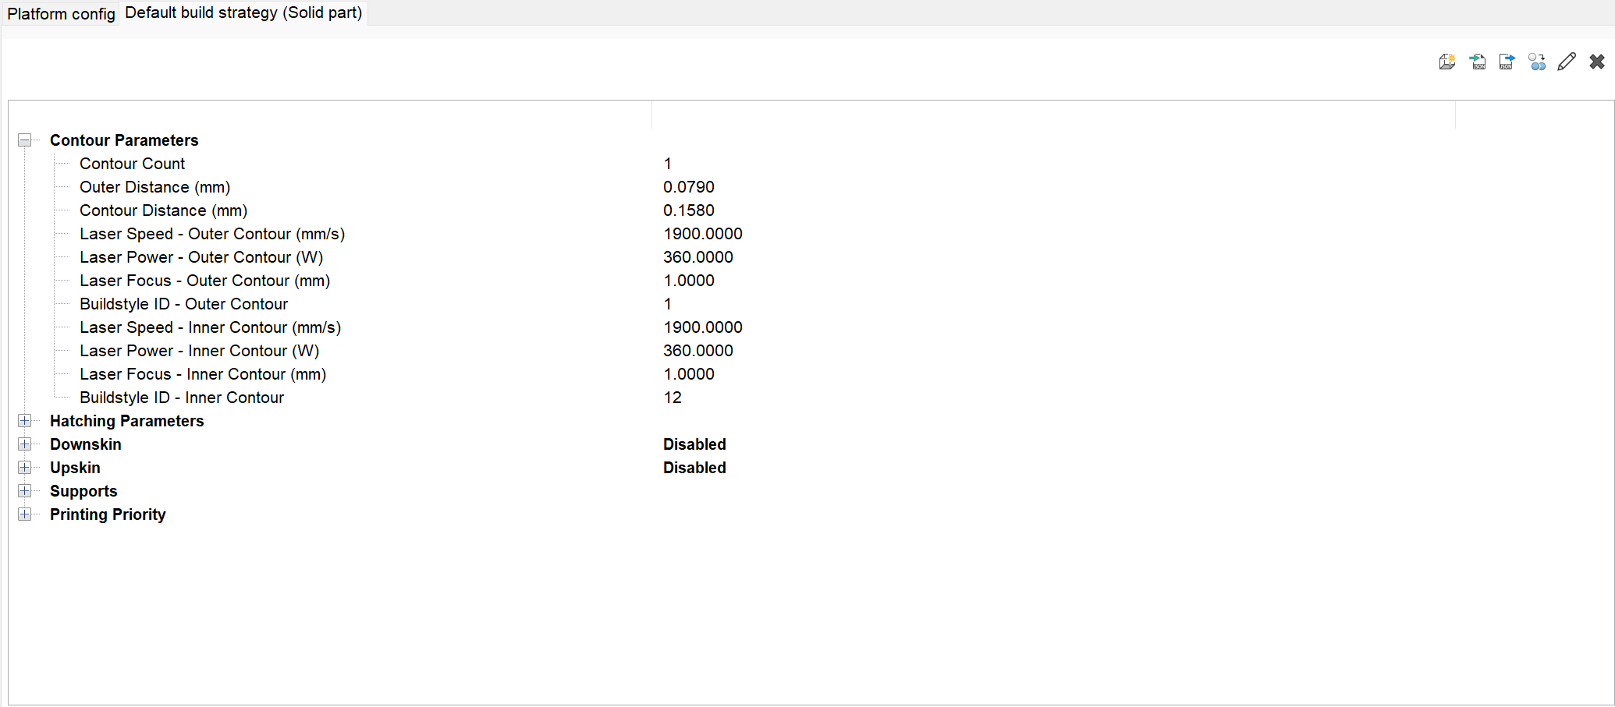
Unsure
Unsure
Known
Known
Unsure
Known
Unsure
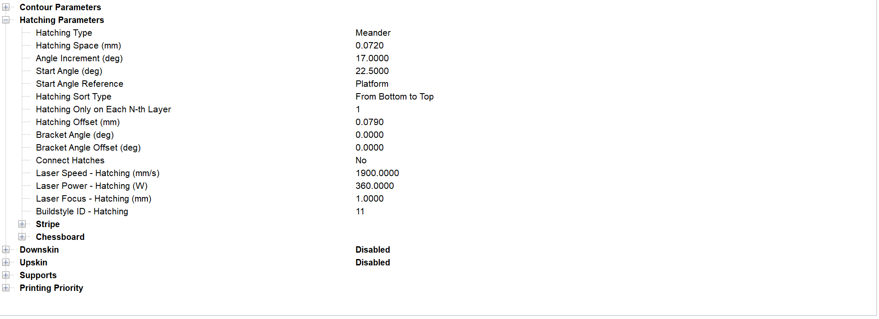
Unsure
Known
Known
Unsure
Known
Known
Unsure
Unsure
Unsure
Unsure
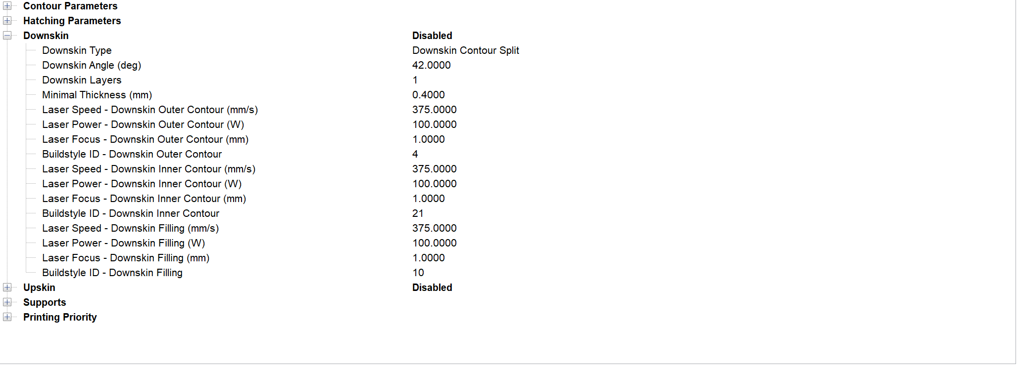
Unsure
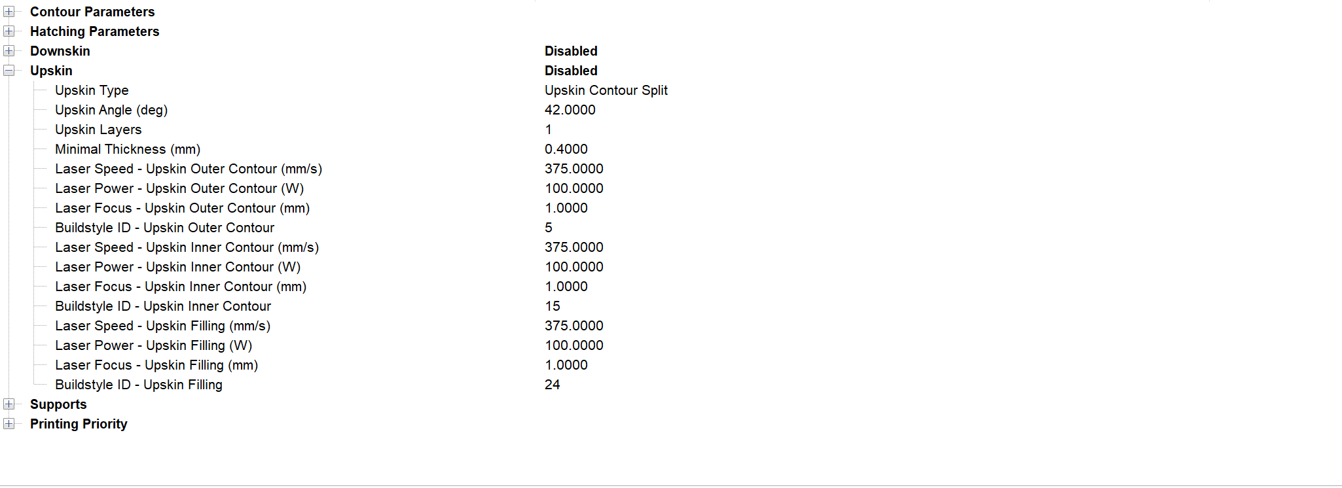
Unsure
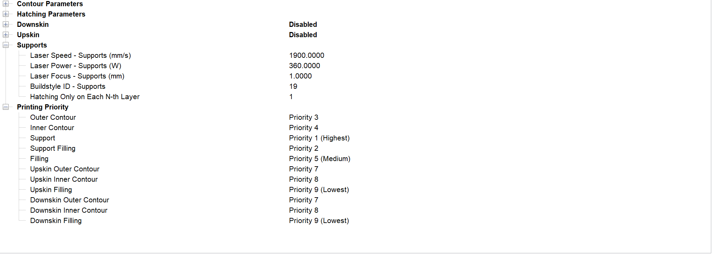
Unsure
Known
Known
Known
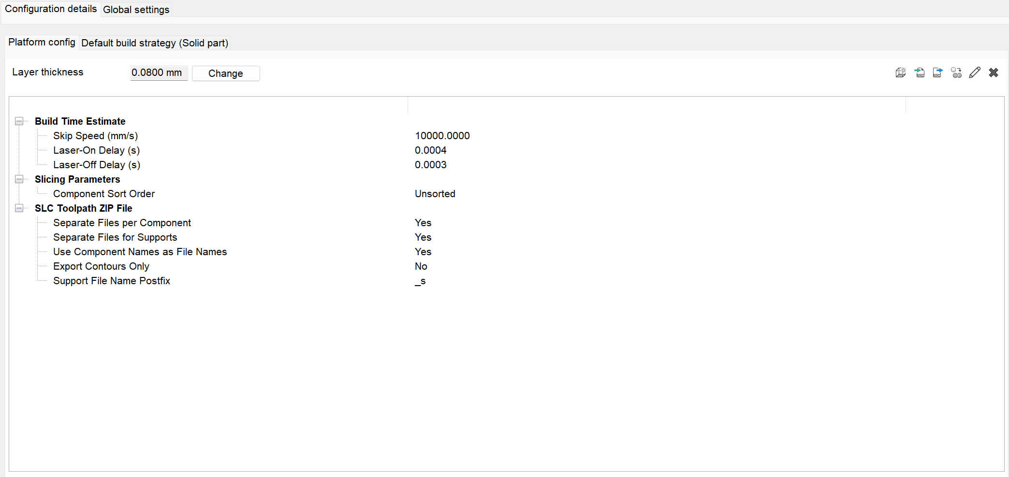
Unsure
Unsure
Known

